SQL queries
- What is the total revenue generated by male vs female
select gender, SUM(purchase_amount) AS revenue from customer
GROUP BY gender
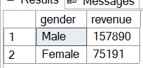
- Which customers used discount but still spent more than the purchase amount?
select customer_id , purchase_amount from customer
WHERE discount_applied = 'Yes' and purchase_amount >= (select AVG(purchase_amount) from customer)
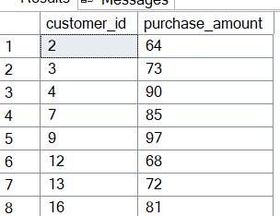
- Which are the top 5 products with the highest average review rating?
select TOP 5 item_purchased, ROUND(AVG(review_rating),2) AS 'Average product rating' from customer
GROUP BY item_purchased
ORDER BY [Average product rating] DESC
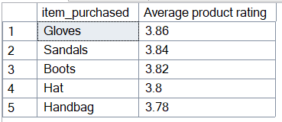
- Compare the average purchase amounts between standard and express shipping?
select shipping_type, AVG(purchase_amount) AS 'Average Purchase amount' from customer
WHERE shipping_type in ('Standard', 'Express')
GROUP BY shipping_type
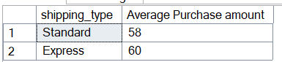
- Do subscribed customers spend more? Compare average spend and total revenue between subscribers and non-subscribers?
select subscription_status, COUNT(customer_id) AS 'Total customers', SUM(purchase_amount)
AS 'Total_revenue', AVG(purchase_amount)
AS 'Average_spend' from customer
GROUP BY subscription_status
ORDER BY Total_revenue DESC
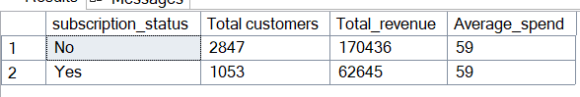
- Which 5 products have the highest percentage of purchases with discounts applied?
select TOP 5 item_purchased,
(100 * SUM(CASE WHEN discount_applied = 'Yes' THEN 1 ELSE 0 END) / COUNT(*)) AS discount_rate
from customer
group by item_purchased
order by discount_rate desc
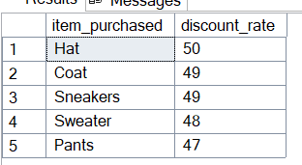
- Segment customers into new, returning and loyal based on their total number of previous purchases and show the count of each segment?
with customer_type as(
select customer_id, previous_purchases,
case
when previous_purchases = 1 then 'New'
when previous_purchases between 2 and 10 then 'Returning'
else 'Loyal'
end as 'customer_segment'
from customer
)

select customer_segment, COUNT(*) as 'Number_of_customers' from customer_type
group by customer_segment
order by Number_of_customers desc
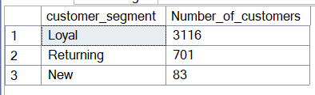
- What are the top 3 most purchased products in each category?
with item_count as (
select category, item_purchased, COUNT(customer_id) as 'total_orders',
row_number() over(partition by category order by count(customer_id) desc) as item_rank
from customer
group by category, item_purchased
)

select item_rank, category, item_purchased, total_orders
from item_count
where item_rank <= 3
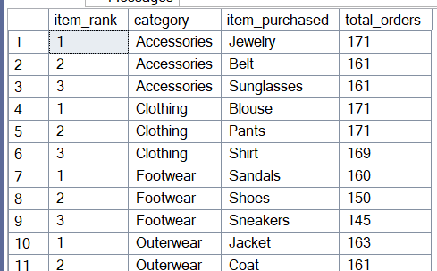
- Are customers who are repeat buyer (more than 5 previous purchases) also likely to subscribe?
select subscription_status,
count(customer_id) as repeat_buyers
from customer
where previous_purchases > 5
group by subscription_status
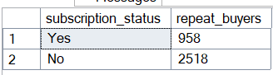
- What is the revenue contribution of each age group?
select age_group,
sum(purchase_amount) as total_revenue
from customer
group by age_group
order by total_revenue desc
